**UV SENSORS**

UV sensors measure the [power](http://www.globalspec.com/datasheets/3478/areaspec/sensor_output_power) or intensity of incident ultraviolet (UV) radiation. This form of electromagnetic radiation has shorter wavelengths than visible radiation, but is still longer than x-rays. UV sensors are used for determining exposure to ultraviolet radiation in laboratory or environmental settings. They are transmitters which respond to one type of energy signal by producing energy signals of a different type. Generally, these output signals are electrical signals that are routed directly to an electrical meter for observation and recording. The generated electrical signals from UV sensors can also be sent to an analog-to-digital converter (ADC), and then to a computer with software for generating graphs and reports.

There are many types of UV sensors. Examples include UV phototubes, light sensors, and UV spectrum sensors. UV phototubes are radiation-sensitive sensors that are used for monitoring UV air treatments, UV water treatments, and solar irradiance. Light sensors are general-purpose devices for measuring the intensity of incident light. UV spectrum sensors are charged coupled devices (CCD) that are used in scientific photography. These UV sensors are also used for measuring the portion of the UV spectrum which sunburns human skin. Ultraviolet light detectors, germicidal UV detectors, and photo stability sensors are also commonly available.

Selecting UV sensors requires an analysis of specifications such as wavelength range, accuracy, power range, weight, and operating temperature. Wavelength range is the range of wavelengths, in nanometers (nm), that UV sensors can detect. UVA radiation ranges over wavelengths from 315 nm to 400 nm. UVB radiation covers wavelengths from 280 nm to 315 nm.  UVC radiation is defined as between 100 nm and 280 nm. Because UVC radiation is more energetic, it is also the most harmful. Accuracy is a measure of how effectively UV sensors measure ultraviolet radiation. Power range and weight are also important parameters to consider, especially for UV sensors that are used in the field. Operating temperature is defined as a full-required range.

UV sensors are used in many different applications. Examples include pharmaceuticals, automobiles, and robotics. UV sensors are also used in the printing industry for solvent handling and dyeing processes. In addition, UV sensors are also used in the chemical industry for the production, storage, and transportation of chemicals.

**Current and Voltage Measurements in a UV Photodiode**

**Introduction**

UV Photodiodes are constructed and operate in similar way to other photodiodes and solar cells. When light falls onto them, electrons are mobilized producing either a current, a voltage or both depending on the operating mode.

This application note will look at each mode giving the advantages and disadvantages of each with reference to UV photodiodes.

**Voltage and Current Mode**

A UV photodiode can be used as a solar cell as shown below:

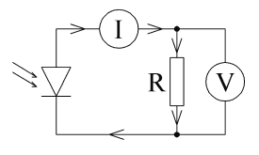

When light falls on the photodiode, a photodiode current is generated which flows from Cathode to Anode of the photodiode. This current can be used to power a load as shown by resistance R in the above circuit. The ammeter and voltmeter are used to monitor the current and voltage in the circuit. To get the maximum power output from the photodiode requires the correct value of R which depends on the characteristics of the photodiode and may change under different light levels.

Using one of our UV photodiodes in the mode is not very useful as the amount of power that can be generated is very small (of the order of nano watts). The output current and voltage are also non-linear with respect to the input light levels so this circuit makes it difficult to make UV measurements.

**Voltage Mode**

By removing the resistor in the above circuit, the current is reduced to zero and just a voltage is produced.

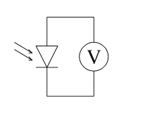

The output voltage produced in this way from our UV sensors is of the order of 50mV under fluorescent lights and of the order of 1V under direct bright sunlight. This makes it easy to make a simple measurement by simply connecting the UV sensor directly to a digital voltmeter. Unfortunately, the output is completely non linear and the relationship is not specified in any of the data sheets. It is therefore not possible to make anything more than crude UV measurements using this method. It is useful though to make a quick check of the operation of the devices.

**Current Mode**

Current mode is the standard method for making measurements with our UV sensors. In this mode, the photodiode is shorted so there is no voltage across the part. The current then produced by the sensor is directly proportional to the light levels falling on the sensor and is linear over many orders of magnitude.

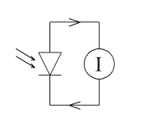

The typical current levels produced are in the nA range which is far below what most digital millimeters will measure. It is therefore necessary to amplify the current produced. The standard way to achieve this is with a transimpedence amplifier which converts the current produced into a voltage.

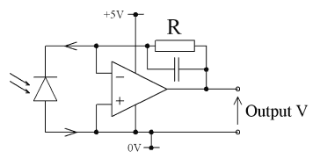

The above circuit requires a rail to rail input and output op-amp which can operate from 5V and has high input impedance. Note that the UV photodiode has been inverted so as to produce a positive output with rising light levels. A resistor R value of 10Mohms will give an overall gain of 107 V/A. A capacitor of around 100pF can also be added to reduce the noise seen at the output.

The output from the op-amp can be amplified further if required and then output to a digital voltmeter or fed into the A to D input of a microcontroller